

Project and Professionalism (6CS020)

A1: Literature Review

Art Gallery Management System

Student ID: 2042471

Student Name: Sujan Pyakurel

Supervisor: Sumanta Silwal

University Email: :  [S.Pyakurel@wlv.ac.uk](mailto:S.Pyakurel@wlv.ac.uk)

Award/Course: BSc Hons Computer Science

Cohort/Batch: 4

Submission Date: October 16, 2020

## 

Contents

1. Existing System 4

1.1 Gallery Today 4

1.2 Qart.com 5

1.3 Great Big Canvas 5

2. Research Papers based on same algorithms used 7

2.1 An Improved Collaborative Filtering Recommendation Algorithm 7

2.2 Movie Recommender System Using Collaborative Filtering 7

2.3.1 Content-based Filtering 7

2.3.2 Collaborative Filtering (CF) 8

Bibliography 11

Table of Figures

Figure 1 Gallery Today's webapp(Gallery Today, 2020) 4

Figure 2 Quart Online Art gallery(Quality Art Auctions, 2020) 5

Figure 3 Great Big Canvas online Art gallery(Great Big Canvas, 2020) 6

Figure 4 Content-based filtering 7

Figure 5 Demonstration of user-based CF 8

Figure 6Demonstration of item based CF 9

## 1. Existing System

The following 3 are the web applications which are similar to my project and their brief description.

### 1.1 Gallery Today

It is an international online art gallery that has artworks featured in the website mostly from American artists. In this art gallery people can search for paintings on the basis of subjects ( Abstract Art, Floral Art, Nude Art, etc.), art styles(Surrealism Art, Realism Art, Decorative Art, etc.), art type(Oil Paintings, Acrylic paintings, Watercolor Paintings, etc.) and name of artists. This application has features like search button, checkout system and payment system.

The following are the features of this web application:

* User management system for both customers and artists
* We can search for paintings using keywords like type, artists of paintings.
* We can get the general information about any painting in this site.
* People can add the paintings they would like to buy in shopping cart
* It also has checkout management system for the confirmation before customer can buy.
* Payments acceptance through various international paying systems like Visa card, MasterCard, PayPal etc.(Gallery Today, 2020)

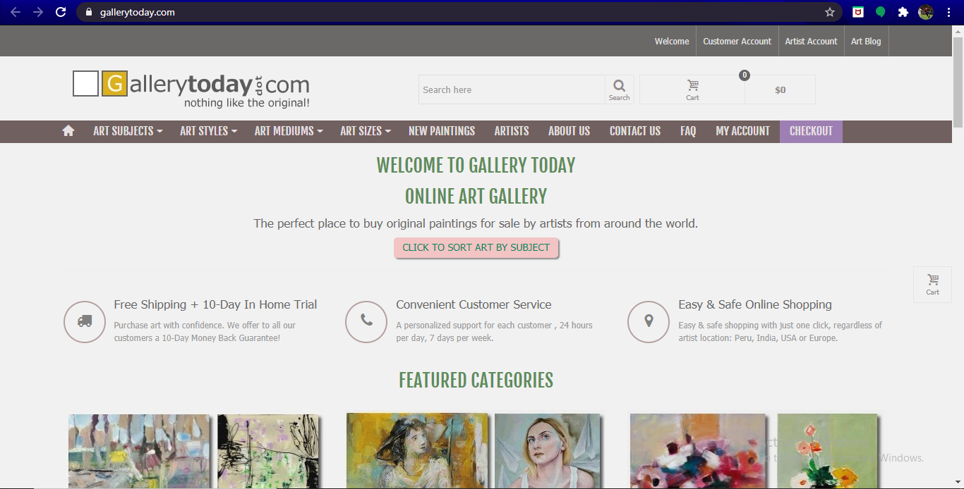

Figure 1 Gallery Today's webapp(Gallery Today, 2020)

### 1.2 Qart.com

This is another online website that connects art lovers virtually. People can view artworks in this site without creating account. But for buying and adding the paintings in gallery, account must be created prior to the actions. People can view artworks on the basis of popularity, originality, animation arts, comic book arts, and also by searching the name of artists.

The following are the special features of this web application.

* Common user management system for customers and artists.
* Customers can sort the paintings by type, artists and page.
* Customers can view detail description of paintings and bibliography of artists.
* People can add paintings and artworks they like in their web gallery after sign up and login.
* Customers can add paintings in shopping cart, checkout before shop and pay through various international means like Visa card, MasterCard, American Express and PayPal.

(Quality Art Auctions, 2020)

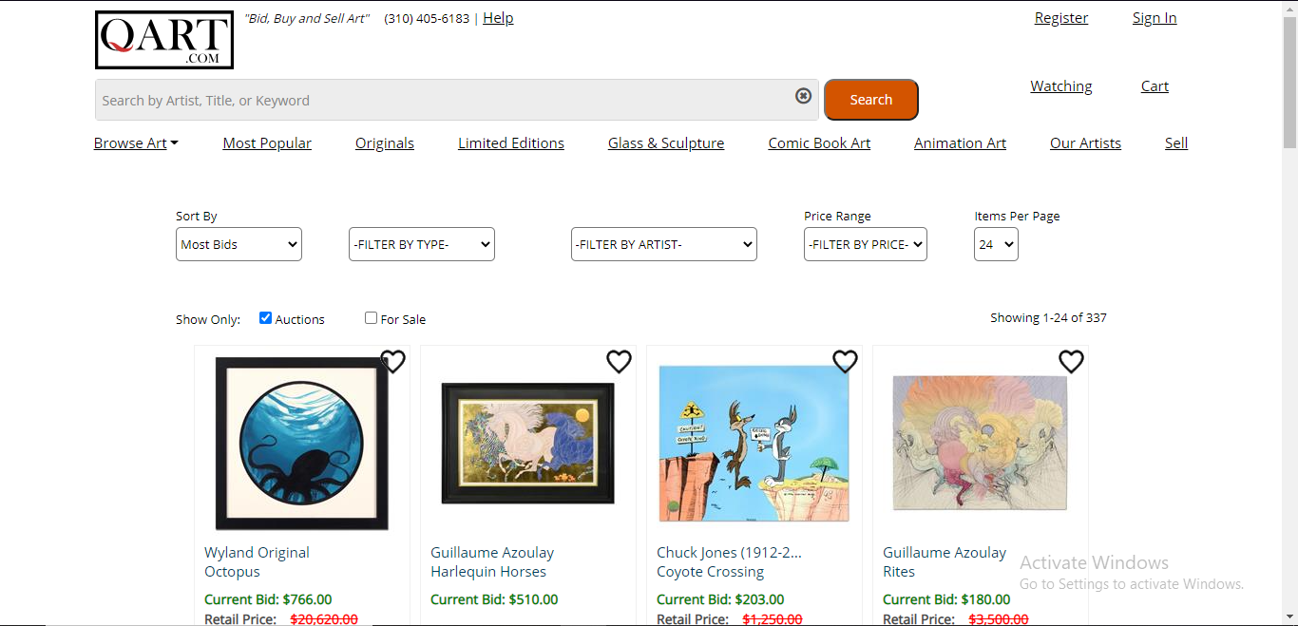

Figure 2 Quart Online Art gallery(Quality Art Auctions, 2020)

### 1.3 Great Big Canvas

This is one of the best online site that deals with selling of arts and is a huge art gallery that has over 700,000 pieces of arts from popular abstract arts to stunning photography. This site has classified arts as best sellers, subjects, styles, artists, collections and so on. We can also search arts and photographs of shape and colors we like.

The following are the features of this web application:

* This web application also has user management system.
* We can search paintings and photographs by using key words such as title, artists, types, subjects of paintings.
* Guests and customers can add artworks in “My Gallery” section and can view it as collections.
* This website has money back policy as well within a year.
* This web app records billing and shipping addresses before confirmation of payment of the artworks we want to shop as checkouts.
* We can find link to different social media accounts of this web app such as facebook, twitter, Pin Interest, Instagram, etc.(Great Big Canvas, 2020)

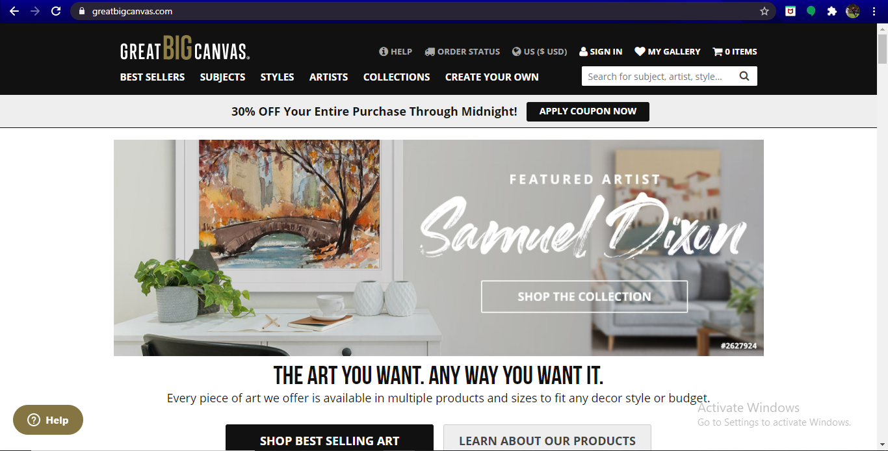

Figure 3 Great Big Canvas online Art gallery(Great Big Canvas, 2020)

# 2. Research Papers based on same algorithms used

The following are some of the research papers I have done research on based on Collaborative Filtering algorithm.

## 2.1 An Improved Collaborative Filtering Recommendation Algorithm

The oldest suggested approach in recommendation system is Collaborative Filtering Recommendation (CFR). This algorithm is often used simultaneously to see what customers are really interested in as well as to figure out the formation of implicit interest. Recommendations can be much effective as data by volume and time increases. The recommendation for Collaborative filtering is by far the most prominent recommendation algorithm in recommendation system for e-commerce. Though the system is much effective in long run, it might face some difficulties in start, sparse might be slow, cold real-time and optimization etc. challenges that may affect recommendation performance. (Hong-xia, 2019)

## 2.2 Movie Recommender System Using Collaborative Filtering

### 2.3.1 Content-based Filtering

This recommendation system needs some data and information on what the user might like or what he has watched before. It is based on previous actions. This system may not be much acceptable for industry as they require data and are not much more reliable. (Gupta et al., 2020)

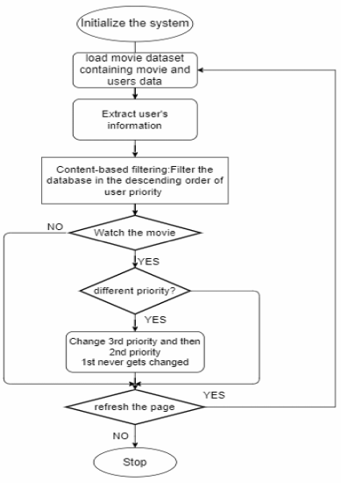

Figure 4 Content-based filtering

### 2.3.2 Collaborative Filtering (CF)

This system filters out the contents based on similar interests with other users. It basically recommends the items to the users that have similar taste. This algorithm is much famous and popular in industry. There are two popular filtering algorithms in the memory-based techniques. Figures below describes items based and user based collaborative filtering. (Gupta et al., 2020)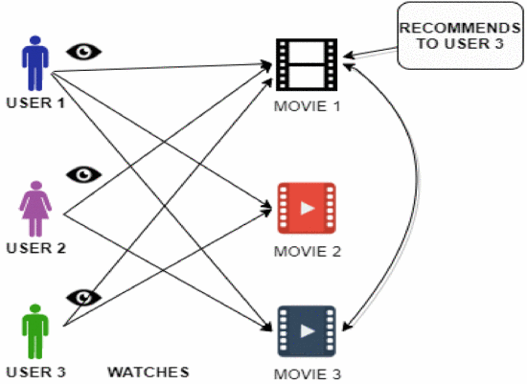

Figure 5 Demonstration of user-based CF

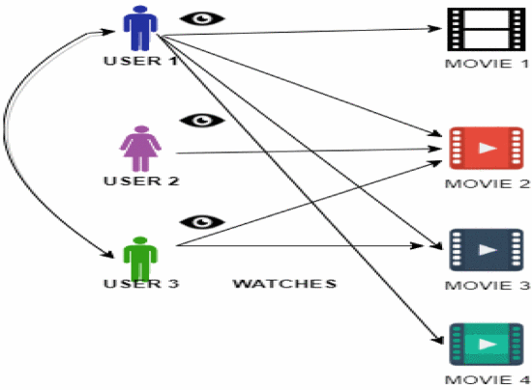

Figure 6Demonstration of item based CF

# Bibliography

Gallery Today, 2020. *WELCOME TO GALLERY TODAY*. [Online] Available at: <https://www.gallerytoday.com/> [Accessed 17 September 2020].

Great Big Canvas, 2020. *The Art You Want. Any Way You Want It.* [Online] Available at: <https://www.greatbigcanvas.com/> [Accessed 17 September 2020].

Gupta, M. et al., 2020. *Movie Recommender System Using Collaborative Filtering*. Coimbatore, India: IEEE 2020 International Conference on Electronics and Sustainable Communication Systems (ICESC).

Hong-xia, W., 2019. *An Improved Collaborative Filtering Recommendation Algorithm*. Suzhou, ChinaSuzhou, China: IEEE 2019 IEEE 4th International Conference on Big Data Analytics (ICBDA).

Quality Art Auctions, 2020. [Online] Available at: <https://www.qart.com/> [Accessed 17 September 2020].